**EBS**

1. **Ensure your region is set to “N Virginia”**

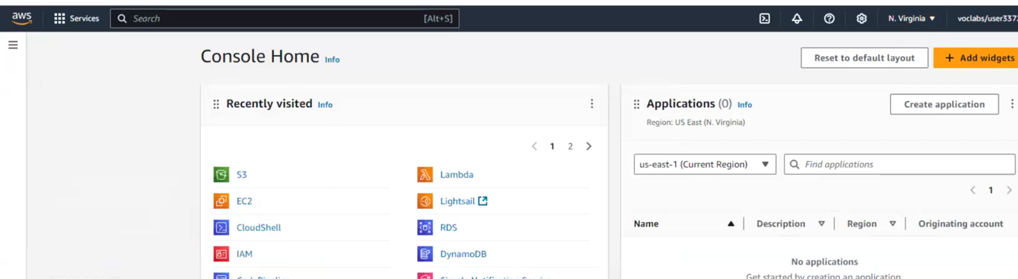

1. **Create 1 EC2 instance using he 7 step workflow**
2. **Use the usual Amazon Linux AMI in AZ1**

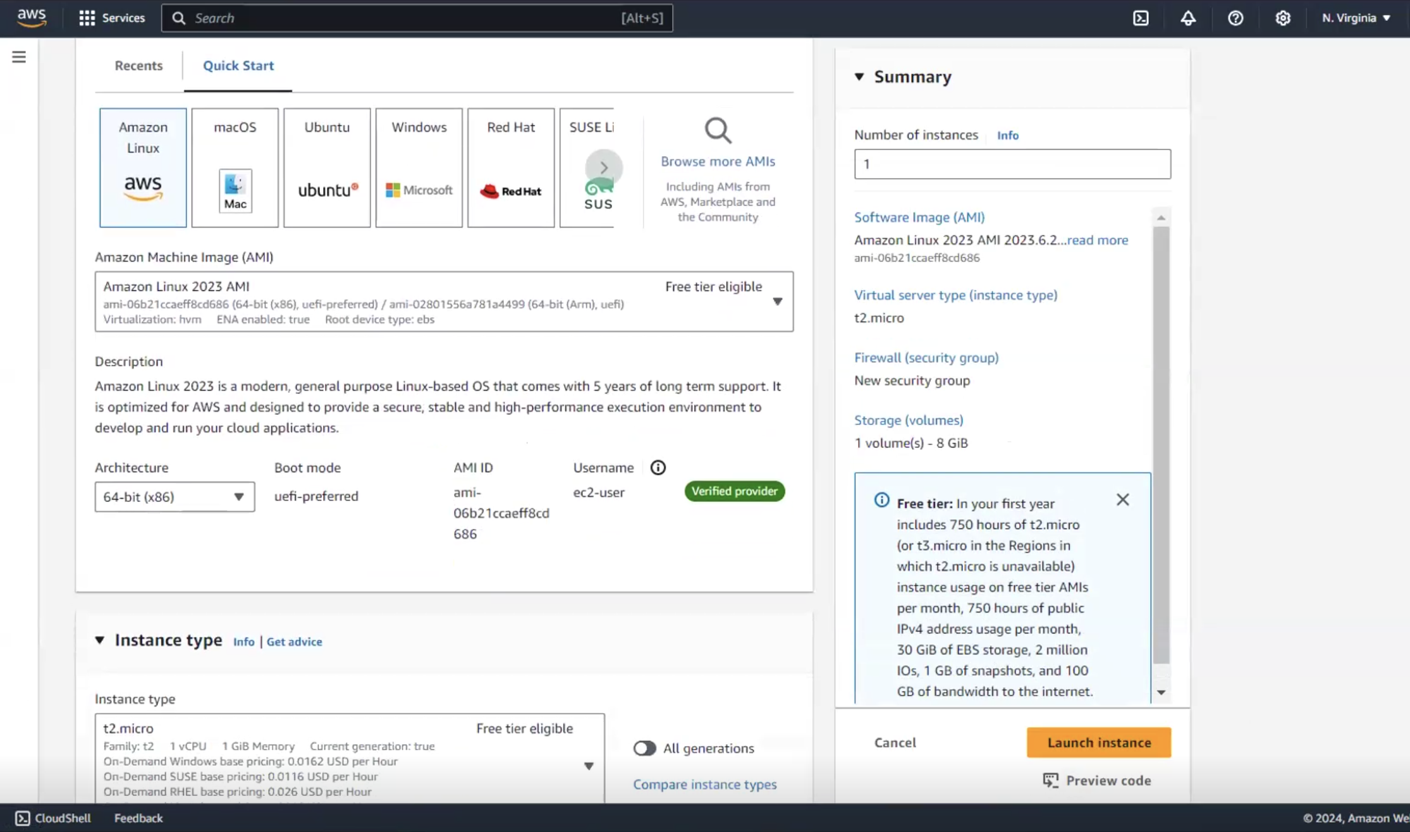

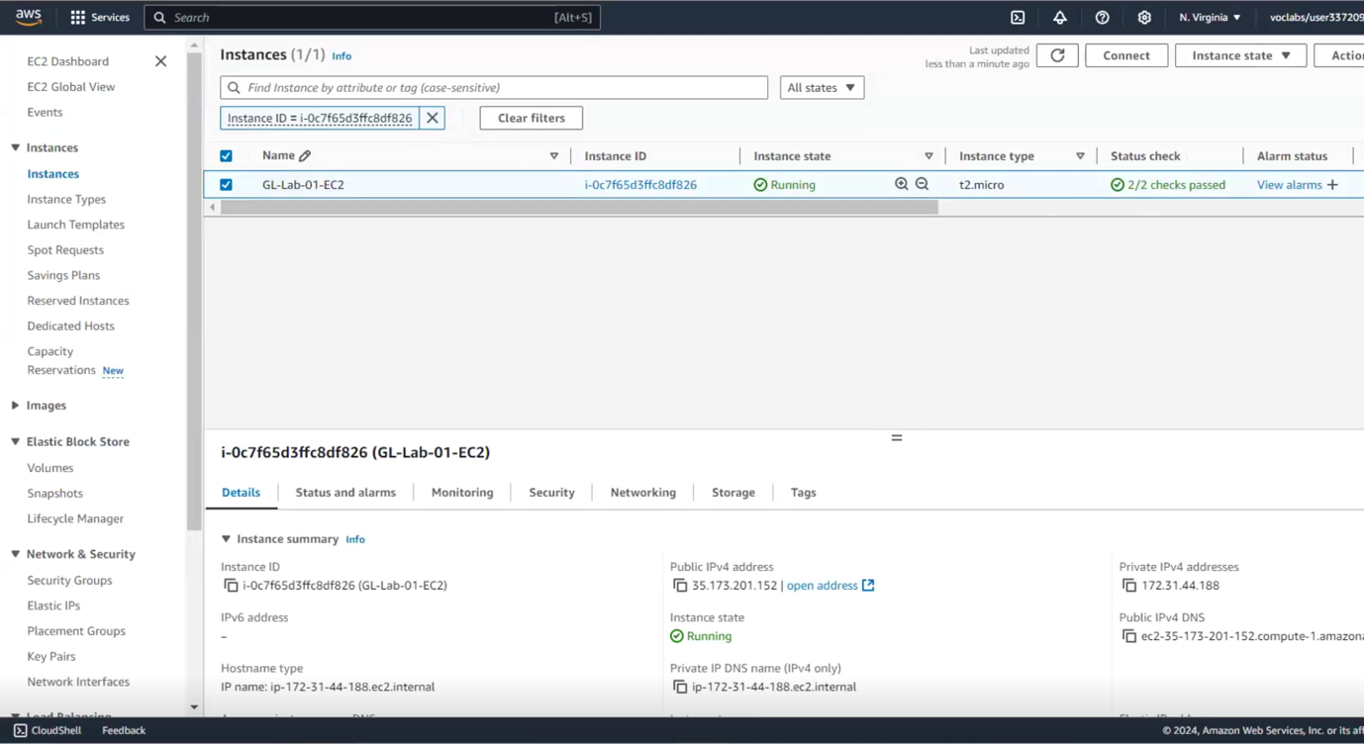

1. **Download a new PEM file and SSH to the instance**

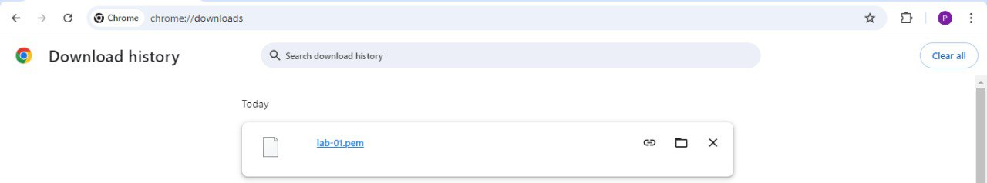

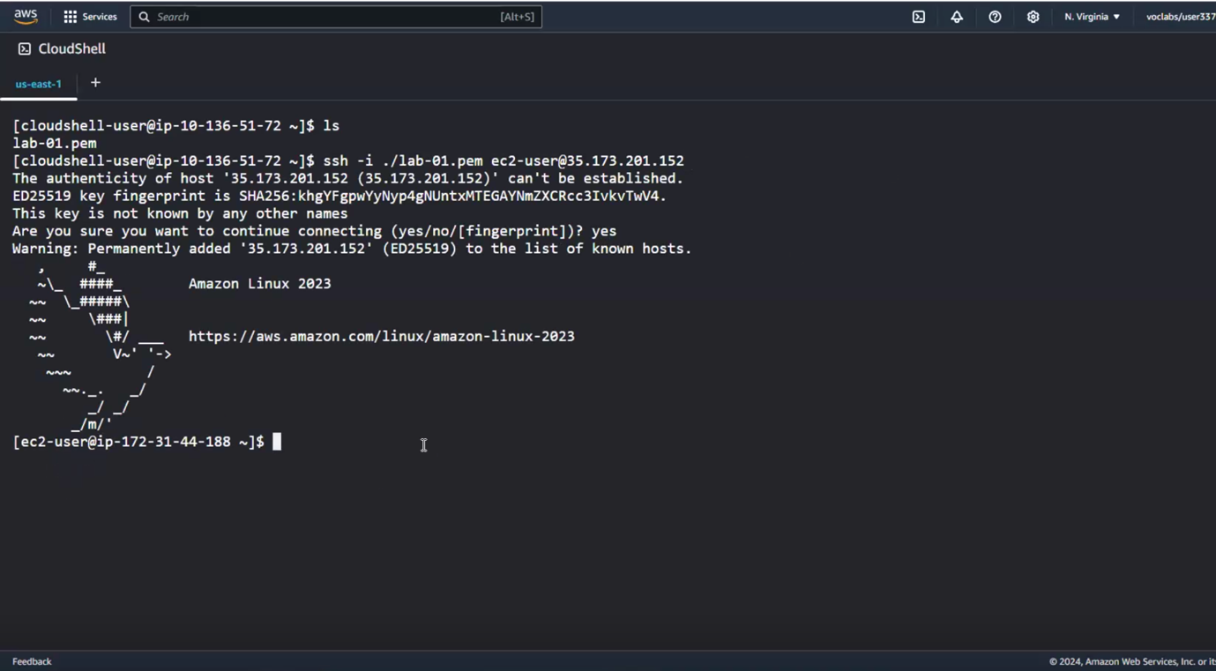

1. **Volumes**
2. **Use the console to get a 10G magnetic volume in the same AZ1**

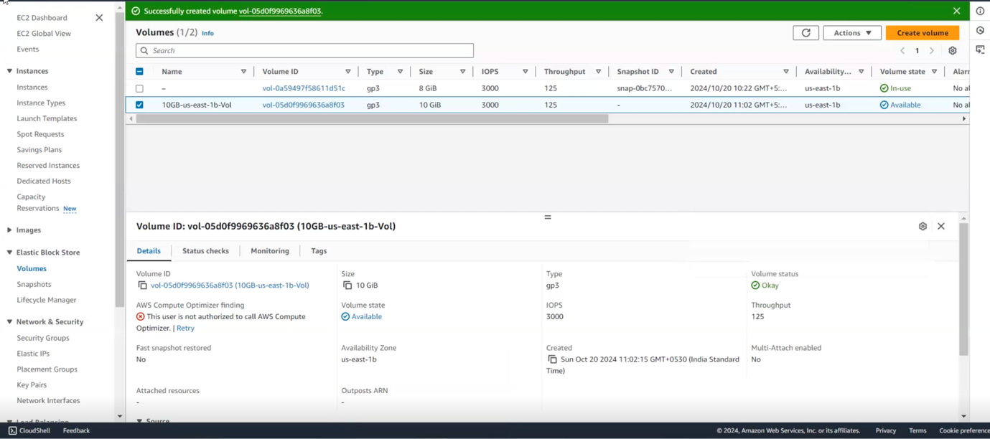

1. **Attach the volume to the instance**

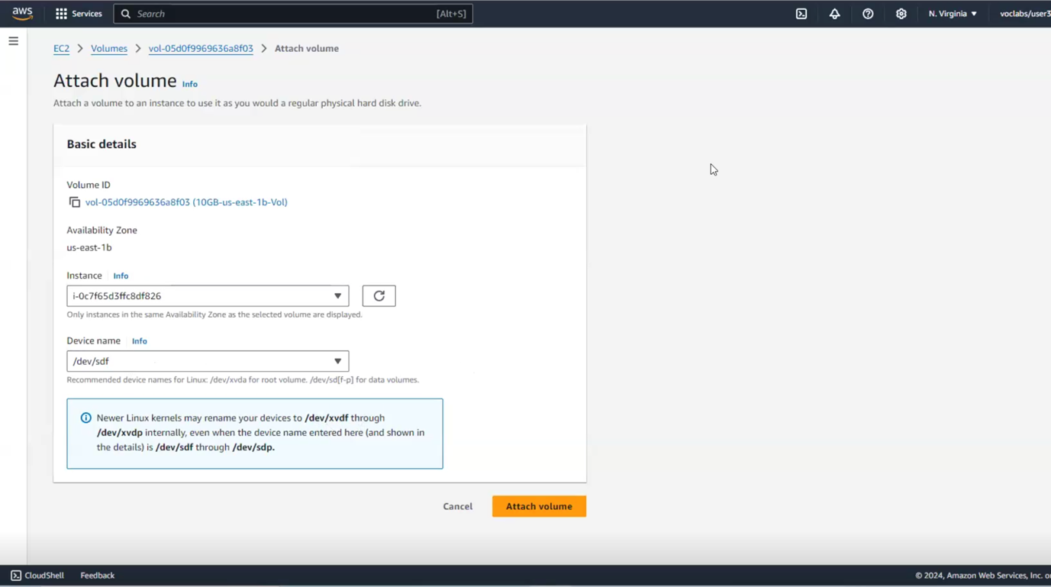

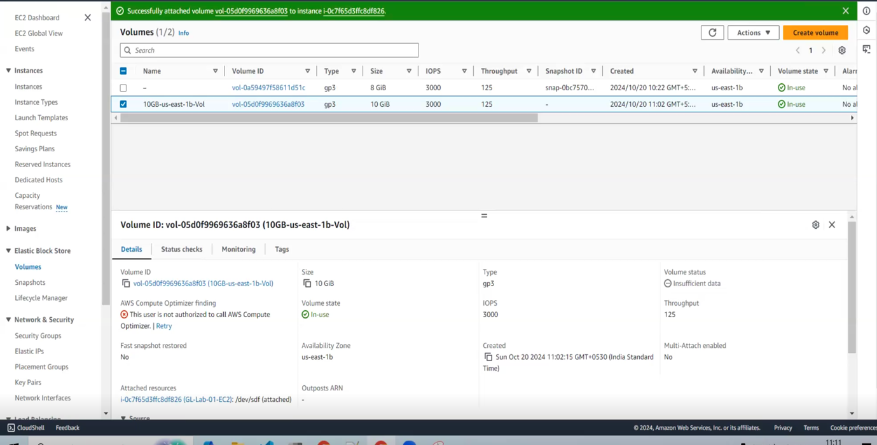

1. **Format the volume and mount it**

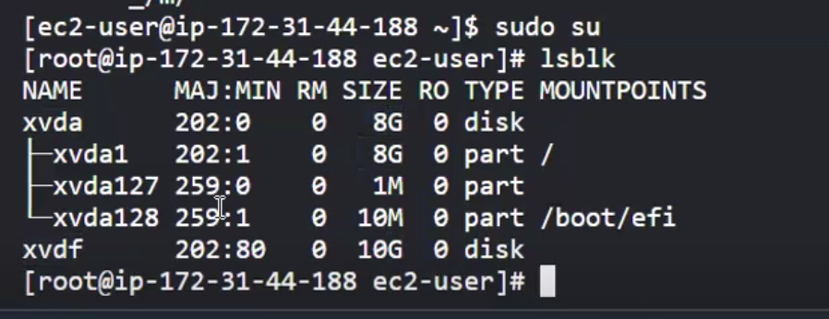



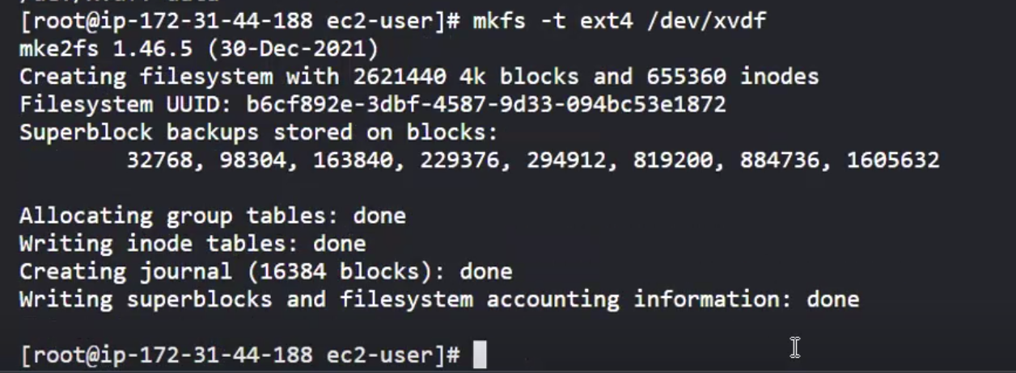



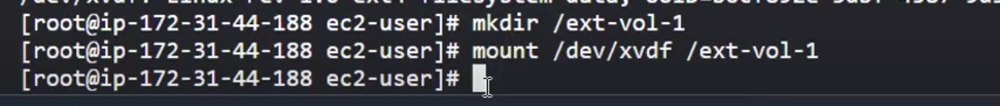

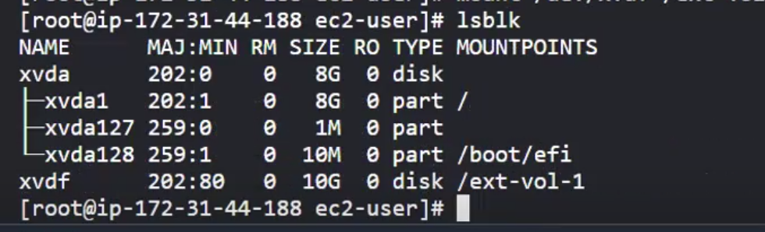

1. **Create a sample text file in the volume to simulate data creation**

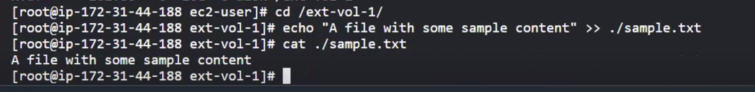

1. **Unmount, detach the volume**

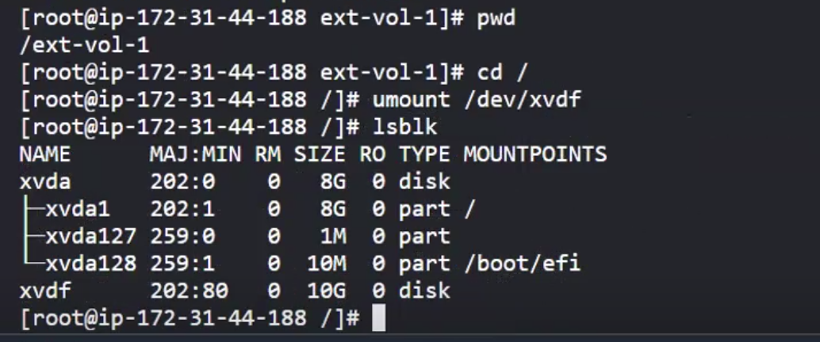

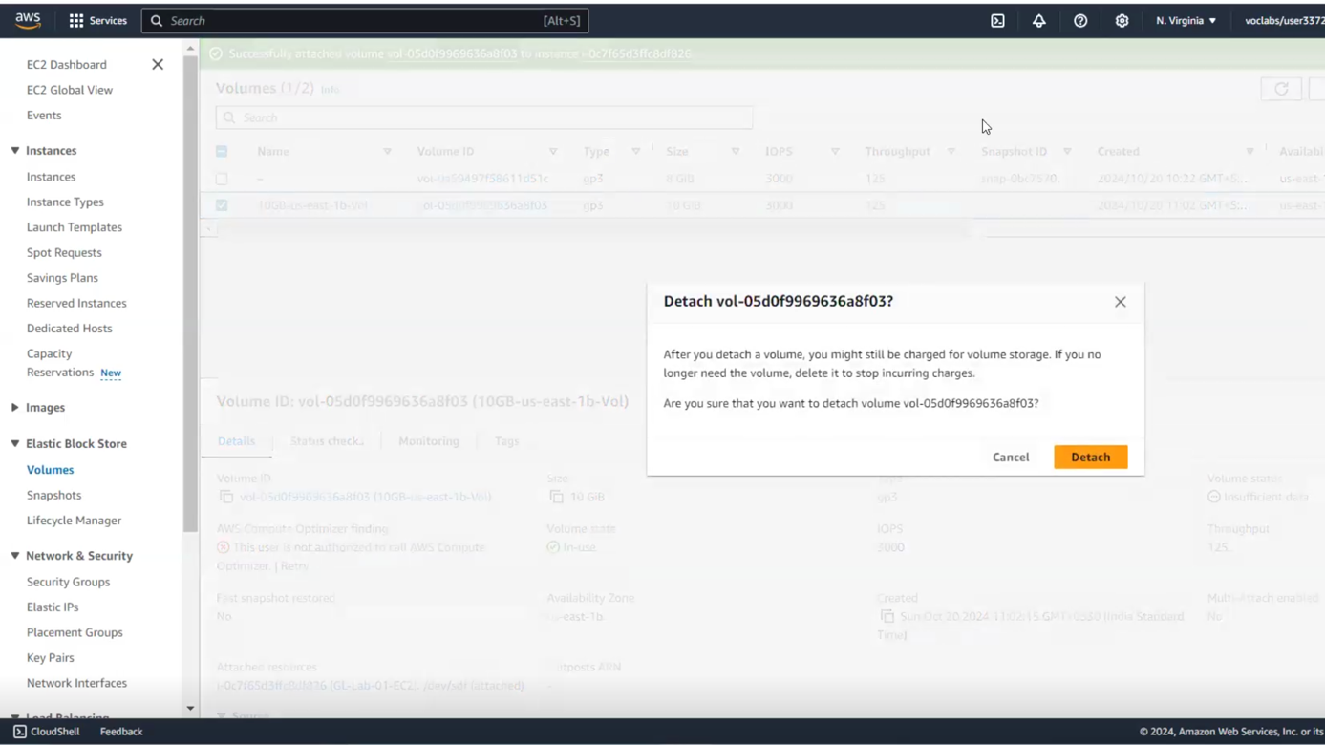

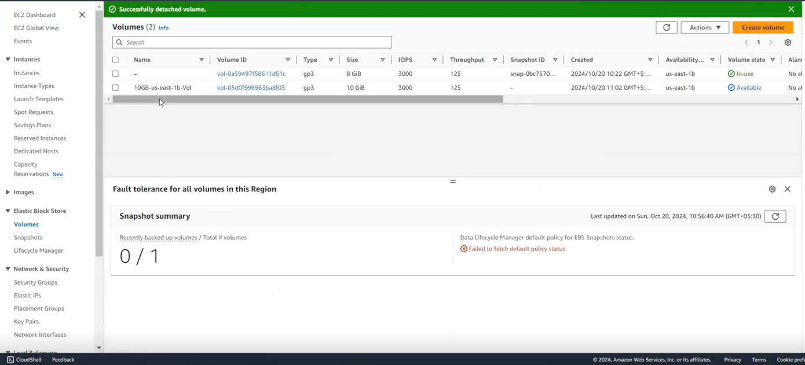

1. **Snapshot**
2. **Create a snapshot of the detached volume**

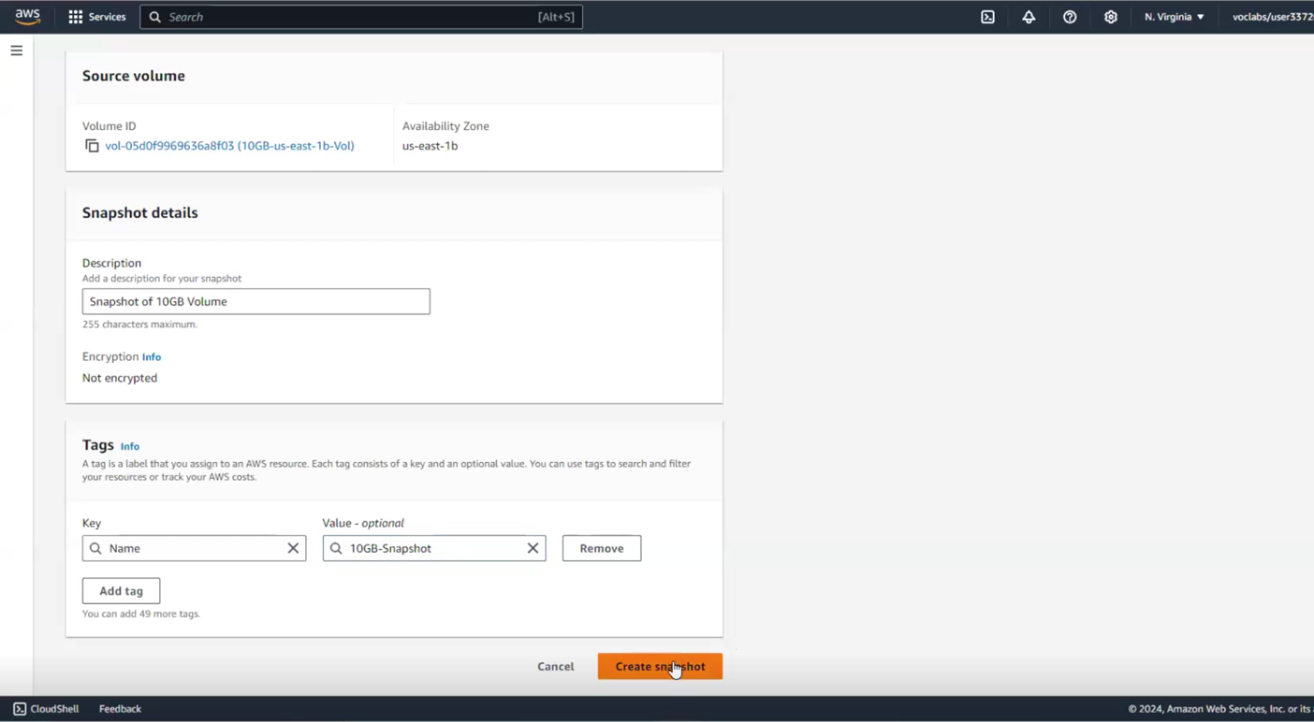

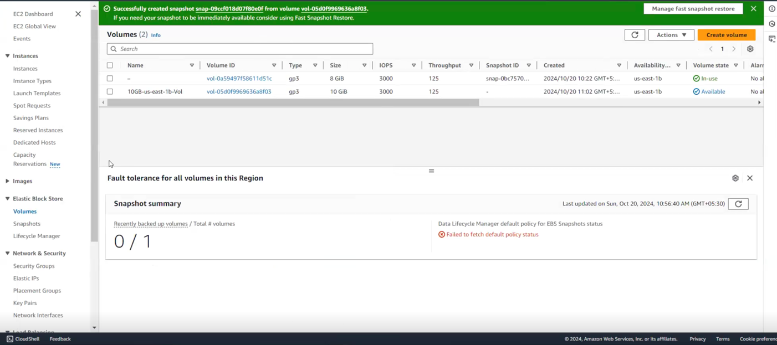

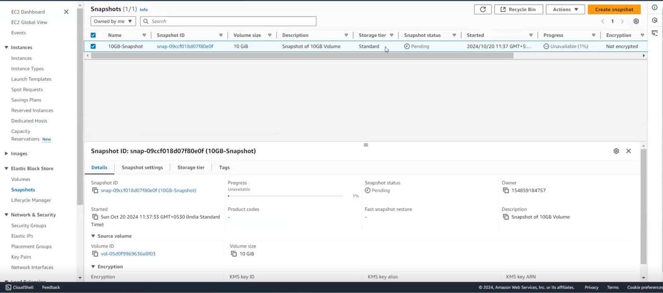

1. **Create a new SSD volume of 15G and apply the snapshot to it**

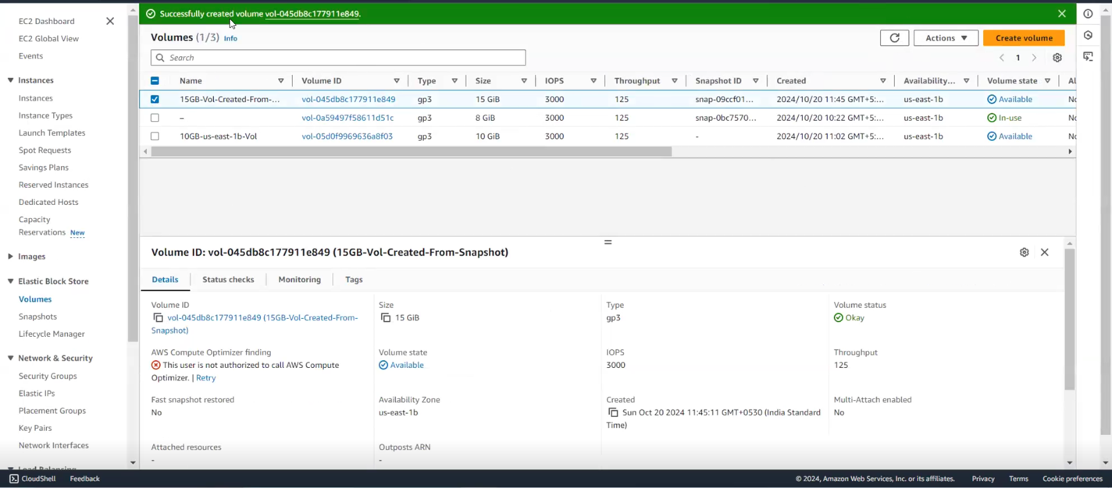

1. **Attach, mount and check if the data is there**

